|  |  |  |
| --- | --- | --- |
| FORM 2  THE PATENTS ACT 1970  39 of 1970  &  The Patent Rules 2003  **COMPLETE SPECIFICATION**  (see sections 10 & rule 13) | | |
| 1. **TITLE OF THE INVENTION**   **“IOT - BASED SMART CONTROL USING HAND GESTURE”** | | |
| 1. **APPLICANTS (S)** | | |
| **NAME** | **NATIONALITY** | **ADDRESS** |
| 1. Dr. Akhilesh A. Waoo, AKS University, SATNA, MP, India | **Indian** | Department of Computer Science, Faculty of Engineering and Technology, AKS University, Satna, (M.P.), INDIA, 485001. |
| 1. Harshit Pandey, AKS University, SATNA, MP, India | **Indian** | Department of Computer Science, Faculty of Engineering and Technology, AKS University, Satna, (M.P.), INDIA, 485001. |
| 1. AKS University, SATNA, MP, India | **Indian** | AKS University, Satna, (M.P.), INDIA, 485001. |
| 1. **PREAMBLE TO THE DESCRIPTION** | | |
| **COMPLETESPECIFICATION**  The following specification particularly describes the invention and the manner in which it is to be performed. | | |

**FIELD OF THE INVENTION**

1. Computer Science – Gesture Recognition Devise

**BACKGROUND OF THE INVENTION**

This invention utilizes computer vision techniques to track hand gestures and translate them into keyboard actions. By capturing video frames from a webcam, the system detects and processes hand landmarks using the Mediapipe library. Specific hand gestures are mapped to predefined actions, such as pressing the arrow keys to navigate through slides or adjusting the zoom level.

**Background**

1. Hand Gesture Recognition
2. Mediapipe Framework
3. Computer Vision Techniques
4. PyAutoGUI

**Gesture-Based Controls**

A ) Left and Right Movement

B ) Up and Down Movement

C ) Zoom Functionality

**SUMMARY OF THE INVENTION**

1. The present invention

In today's rapidly evolving educational landscape, the demand for innovative teaching tools is at an all-time high. Traditional methods of presentation control often disrupt communication between educators and students. To address this challenge, we propose an advanced IoT-based smart screen control system tailored specifically for educational settings. At the core of our system lies hand gesture recognition technology powered by the MediaPipe library, renowned for its accuracy. This technology enables real-time detection and tracking of hand gestures, providing educators with a seamless method of controlling presentations.

Our user-friendly interface empowers educators to navigate slides, interact with multimedia content, and engage with students effortlessly, all through natural hand movements. To ensure a smooth experience, we integrate camera sensors and microcontrollers to transmit data to computers interfacing with smart boards. Our advanced algorithm synchronizes hand feed and movement flawlessly, guaranteeing a glitch-free user experience. Additionally, customization options allow users to tailor settings and gestures to their preferences, enhancing control and personalization. In conclusion, our system represents a significant advancement in presentation control technology, setting a new standard for efficiency and effectiveness in educational settings. By seamlessly integrating hardware and software components, we revolutionize human-computer interaction, empowering educators and inspiring creativity in the classroom.

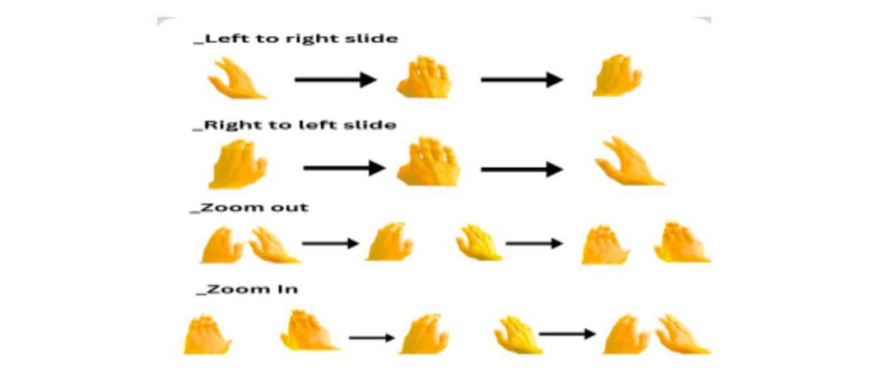**BRIEF DESCRIPTION OF THE DRAWINGS**

Our system operates through a meticulously designed process that seamlessly integrates hardware and software components to facilitate intuitive human-computer integration.

**DETAILED DESCRIPTION OF THE INVENTION**

**Introduction**

1. In today’s fast-paced educational landscape, the demand for innovative teaching tools and technologies is ever-growing. Traditional methods of presentation control, reliant on handheld devices or computer peripherals, often disrupt the flow of communication between educators and students. To address this challenge, we propose a groundbreaking solution that leverages cutting–edge technology to redefine the presentation experience in educational institutions.

**Keywords**

Media pipe, IOT, camera sensors, microcontrollers, presentation control customization educational environments, human-computer interaction open CV, python.

**Research gap**

The research gap that the proposed project intends to fill is the lack of specialized adaptation of hand gesture control specifically designed for presentation in teaching organizations.

**Implement and Working**

**Library**

Midea pipe: - we utilize Mediapipe which is an open–source framework developed by Google that provides a comprehensive solution for building real-time multi-modal (e.g. video, audio ) perceptual pipelines These pipelines can be utilized for various applications such as object detection, face detection such as object detection and more. Mediapipe helps us in hand detection with high accuracy.

PyAutogui:- we utilize pyautogui which is a Python library that enables the automation of GUI(graphical user interface) interaction on the desktop. It allows you to programmatically control the mouse and keyboard to perform tasks like clicking, dragging, typing, and more, Pyautogui is cross – a platform meaning it is useful for automating repetitive tasks across different operation systems. It helps us to work with the keyboard to control the buttons of the keyboard.

Open CV: - we have also utilized open CV to work with the camera and computer vision technology and it allows us to detect images and work with the images process them and utilize them in a manner as we want we have utilized open CV for detecting hands. Using a pre-trained media pipe library to detect hands and it allow us to develop a system which is used to control the whole system by hand.

**EXAMPLES:**

Examples scenario :

1 ) Initialization

* You create an instance of the ‘ handgesturecontroller’ class.
* You call the ‘ execute’ method to start the system.

2) Video capture and processing :

* The ‘execute’ method initializes the mediapipe hand's solution and starts capturing video from the webcam.
* The ‘main ’ method runs a loop that continuously reads frames from the webcam

3) Hand landmarks detection :

* For each frame , the ‘detect _ hand _landmarks’ method is called .
* This method processes the frame to detect hand landmarks and draws them in the frame.
* It calculates the x and y coordinates of the first two detected hands.

4) Gesture recognition :

* If two hands are detected their distance is measured to potentially trigger a zoom action (using a hypothetical ‘ zoom ’ function)
* If only one hand is detected, its position is used to determine the gesture and trigger the corresponding keyboard action:

A) left gesture.

B) right gesture.

C) up gesture.

D) down gesture.

**WE CLAIM:**

Dated this 13h day of June 2024

Agent for Applicants:

(Signed) 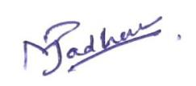Mahesh Madanrao Jadhav

Indian Patent Agent (IN/PA/2087)

To,

The Controller of Patents

The Patent Office Branch, Mumbai

**ABSTRACT**

In today's dynamic educational environment, the demand for innovative tools to enhance teaching methodologies is paramount. This research paper proposes a novel IoT-based smart screen control system tailored explicitly for educational settings. At its core lies hand gesture recognition technology, powered by the MediaPipe library, facilitating seamless real-time detection and tracking of hand gestures for intuitive presentation control. Integrating camera sensors and microcontrollers, the system ensures precise data transmission to computers interfacing with smart boards. An advanced algorithm synchronizes hand feed and movement flawlessly, offering users a glitch-free experience. The user-friendly interface empowers educators to customize settings and gestures, fostering personalized interactions. Furthermore, the system enables control over various types of presentations and slides, as well as zooming functionality within any opened interface. Through a comprehensive literature review and implementation of state-of-the-art methodologies, this research revolutionizes human-computer interaction in educational environments. By adhering to stringent citation guidelines and considering the quality and relevance of references, this paper contributes to advancing knowledge in the field. The proposed system sets a new standard for efficiency and effectiveness in educational settings, promising to breshape the teaching landscape and inspire creativity in classrooms.